

**Git:**

1. Git is a version Control System (vcs)
2. Git is a vcs because all changes are saved on a remote server.
3. **Repository:** (repo) is a project folder / package for a project.
4. **Github:** it is a one example of remote repository hosting service.
5. **Remote repository:** storing the project folder on a server (github, gitlab)
6. **Local Repository:** local means your computer.
7. **Staging Area:** It is used to send the required number of files.

* Staging area is the area where changes are yet to be committed.

1. **Working Directory:** The files which are not under the tracking status is called working directory. (no commands are run)

* From working directory to Staging area single-single file is transferred.
* From staging area to Local repository and from Local repository to Remote repository batch of files [multiple] are transferred.
* **Add** is used to send the repository from Working directory to Staging area.
* **Commit** is used to send the repository from staging area to local repository.
* **Push** is used to send the repository from local repository to remote repository.
* git init – This command is used to initialize the repository.
* git status – This command is used to get the status of repository.
* git add filename.py - This command is used to add the files from **working directory** to **Staging area**.
* git commit -m “your message” – This command is used to transfer the repository from **Staging area** to **local repository.**
* git remote add origin <https://github.com/sreevardhan99/yourProjectFolder> - This command is used to link your github account.
* git push -u origin main – This command is used to transfer the repository from **local repository** to **Remote repository.**

1. git init - it is used to initialize the git repository.

**O/P:**



1. git status - To check status of repository

**O/P:1**

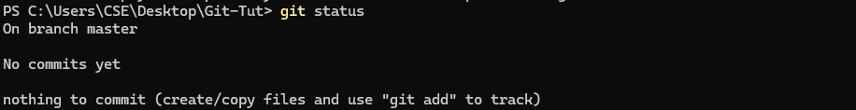

* When you create an any .txt file or anything.
* Untracked files are comes under **Working directory.**

**O/P:2 -** after creating a some files.

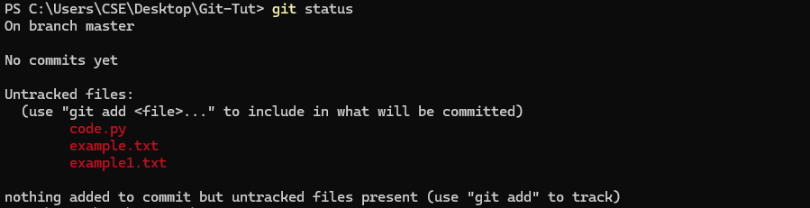

1. git add - It is used to add the files from working directory to staging area.

=> git add code.py

=> git add example.txt

**O/P:**

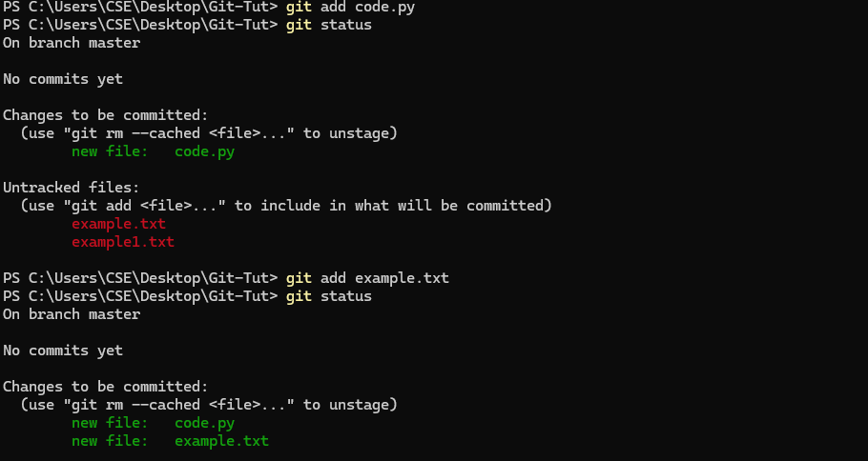

1. git commit - it is used to add files from staging area to local directory.

git commit -m “Comiting code and example files”

**O/P:**

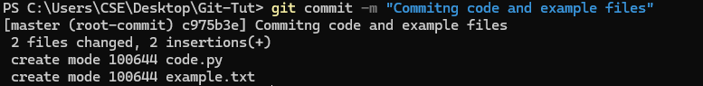

Connecting to github when you created remote repository: same code availabe on your repository.



1. git push - it is used to add files from local repository to remote repository.

git push -u origin master

**O/P:**

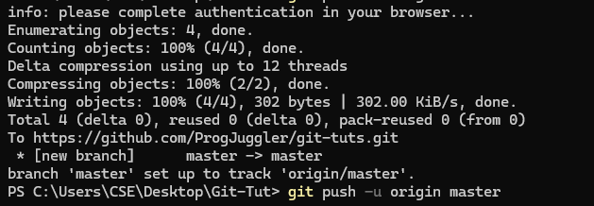

1. git branch - it is used to check the current branch.



**How to create a branch?**

1. git checkout - it is used to create a new branch or switch between difference branches.



**Similarly adding, committing, pushing example.txt in copy1 branch not master branch:**

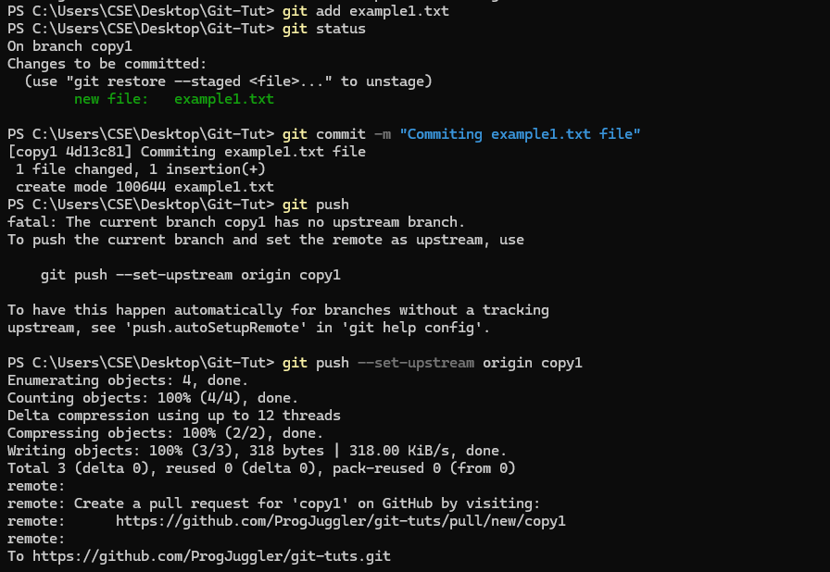

* **To Contribute:**

1. **Fork the repository.**
2. **Copy the http link.**
3. **Create a local folder on your system.**
4. **Open the terminal**
5. **Use the example code below:**

